**Task A**

**Women in athletics**

In order to demonstrate how society has changed in terms of acceptance, representation, and the empowerment of female athletes, this topic highlights the development of women's roles and visibility in sports.   
The magazine "Her Game," which features an article titled "Breaking Boundaries: The Rise of Women in Sports," came to my mind while I was writing this task. The pictures below depict the development of women's roles in sports, which demonstrates tenacity and fortitude.

### 1920s – The First Olympians

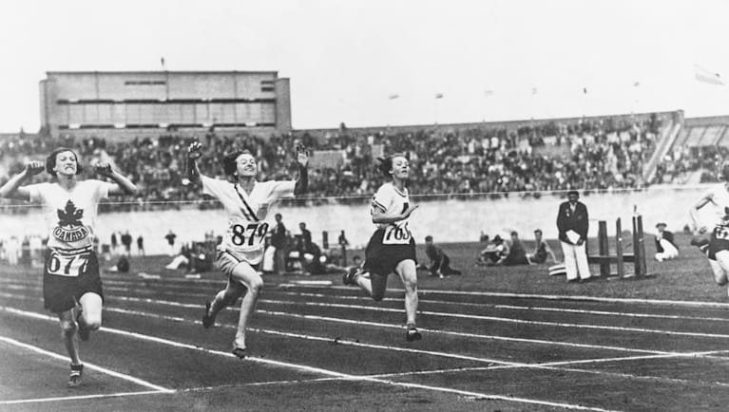

Women participating in track and field events during the 1928 Olympics, one of the first Olympics to include women’s athletics.

The constrictive conventions of the day are reflected in this photograph of female athletes dressed modestly. The early efforts of female players to obtain legitimacy and recognition in a male-dominated sports industry are symbolized by this picture.   
The first Olympic photos of women running track and field from the 1920s highlight the limitations imposed on female athletes. Notwithstanding social criticism, these athletes competed; their modest clothing and small number of events demonstrated how women's sports were viewed as inferior to men's. Lina Radke became the first female Olympic 800m champion in 1928 in Amsterdam.

### 1970s – The Marathon Runner

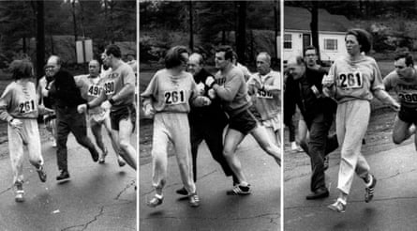

Kathrine Switzer, the first woman to run the Boston Marathon officially in 1967, facing resistance from race officials.

The hurdles women encountered in obtaining equal access to competitive sports are exemplified by this famous picture of Switzer being approached by a race official during the marathon. The image of Kathrine Switzer, the first woman to officially finish the Boston Marathon in the 1970s, is both iconic and defiant. Since more women want to participate in competitive sports, Switzer's race represented a sea change. Title IX, which guaranteed gender equality in school athletics and produced a generation of female athletes, was passed in the US during this time.

### 1990s – The Soccer Champion

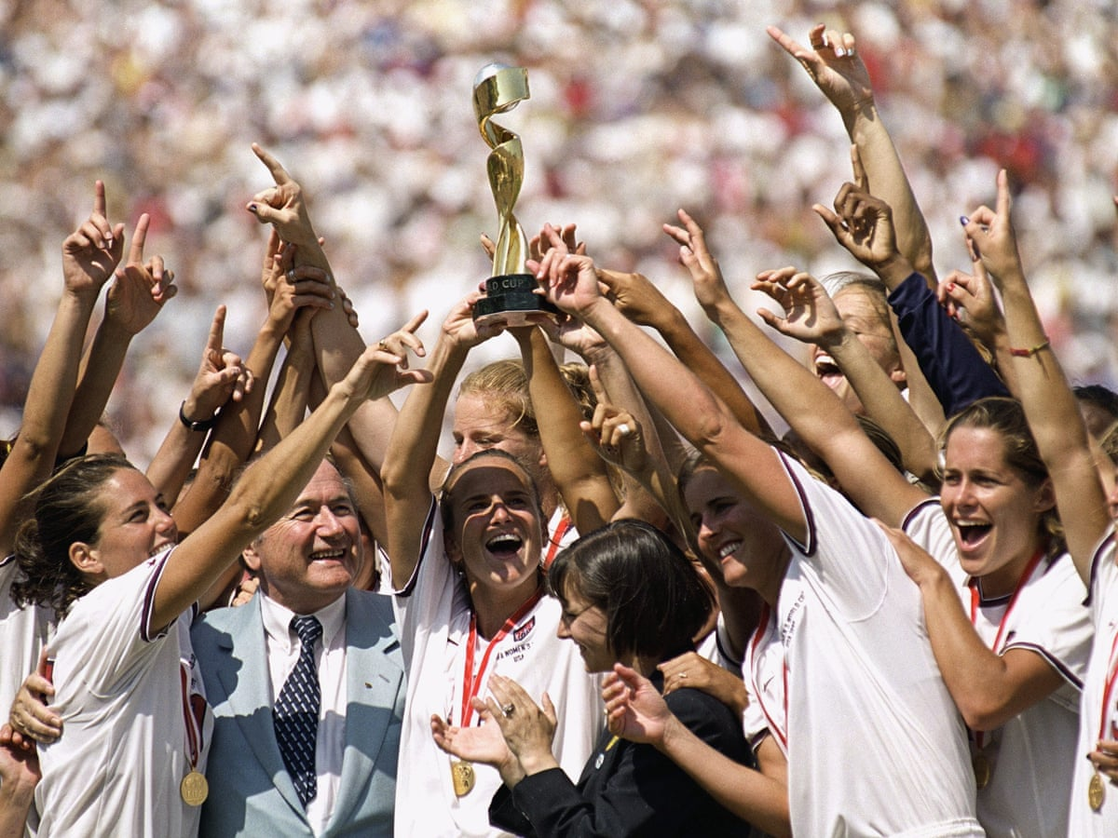

U.S. Women’s National Soccer Team celebrating their 1999 World Cup victory.

This picture captures the team's on-field celebration following their historic victory, which raised awareness of women's soccer and female athletes to a level never seen before.  
The U.S. Women's Soccer Team became world-renowned following their World Cup victory in 1999, sparking a new trend of female athleticism in the 1990s. Photographs of their jubilation signalled a change in culture, with media attention and vast audiences increasingly focused on women's sports. This event turned into a turning point, demonstrating that female athletes could elicit the same level of respect and fervour as their male peers.

### 2024 – The Olympic Gold Medallist

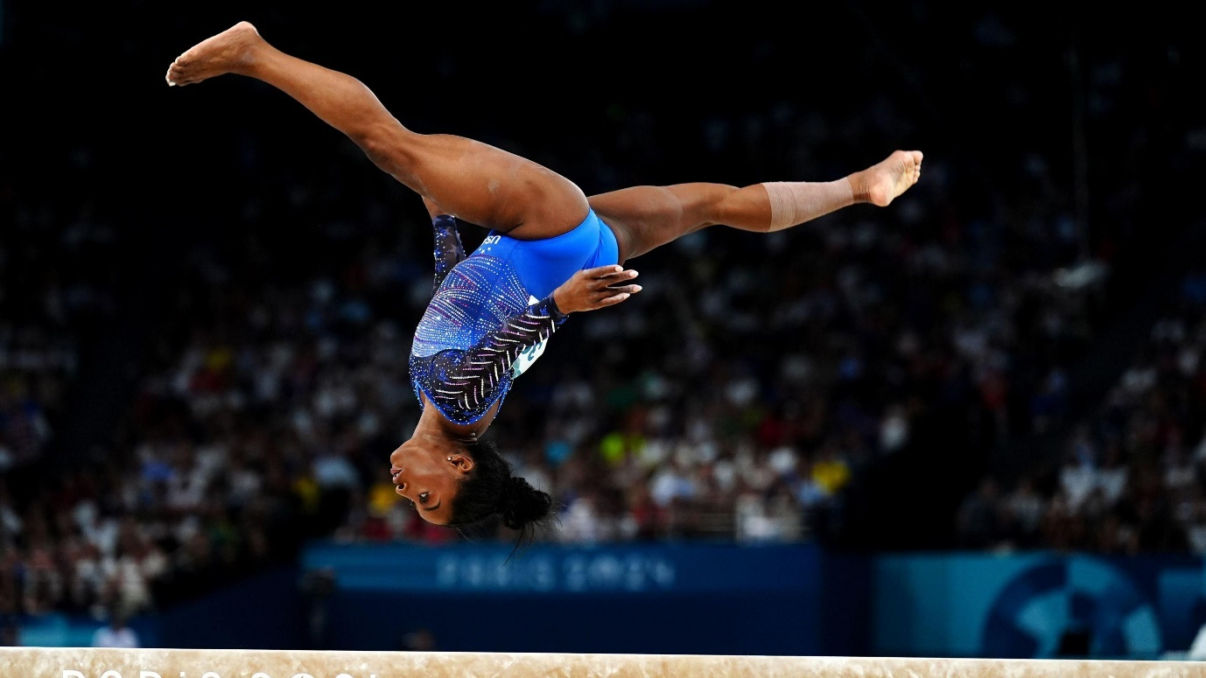

Simone Biles, an Olympic gymnast, performing a challenging routine on the balance beam.

The strength, talent, and grace of contemporary female athletes are encapsulated in this picture of Biles competing in a top-tier event at the 2024 Summer Olympics in Paris. Simone Biles is a symbol of the pinnacle of female athletic success and prominence today. Biles, one of the most decorated gymnasts in history, is a representation of toughness and physical strength. In addition to setting records and becoming role models, female athletes are increasingly competing at the highest levels. Although female athletes are still fighting for equal compensation, recognition, and respect, their pictures show how society views and appreciates them.

From early Olympians to contemporary victors, these pictures show the tenacity of female athletes who have battled to dismantle obstacles and alter public attitudes. From being ostracized athletes to being hailed as icons in the sport, women's journeys are a monument to their resilience and strong will.

**References**

*Olympics.com At Amsterdam 1928, Lina Radke became the first women's Olympic 800m champion, but…* Olympics.com 3rd November. Available at:  
<https://olympics.com/en/news/in-amsterdam-in-1928-lina-radke-was-the-first-female-olympic-800m-champion-but> (Accessed: 11 November 2024).

Alexandra Topping, 2017. *First woman to officially run Boston Marathon does it again – 50 years later.* Marathon running The Guardian 18th April. Available at:  
<https://www.theguardian.com/us-news/2017/apr/18/first-woman-officially-run-boston-marathon-kathrine-switzer-50> (Accessed: 11 November 2024).

Caitlin Murray, 2019*. How the 1999 World Cup champions' biggest win came at the bargaining table*. The National Team: The Inside Story of the Women Who Changed Soccer*.* 2nd April.  
Available at:  
<https://www.theguardian.com/football/2019/jun/09/1999-world-cup-champions-victory-tour> (Accessed: 11 November 2024).

Anonymous, 2024. *Simone Biles wins yet another gold medal.* BBC Newsround 2 August. Available at:   
<https://www.bbc.co.uk/newsround/articles/cn0809g36yyo> (Accessed: 11 November 2024).

**TASK B**

# **Zero-hours Contract**

Tara and Ack, two workers in a busy restaurant, talk about the advantages and disadvantages of zero-hours contracts in the break room. For Tara, a server who depends on her work as her main source of money, the instability is difficult. HR representative Ack feels that the restaurant and some employees need the flexibility that these contracts provide. Their discussion reveals differing opinions about this kind of work.

**Tara:** *[sighing]* My hours vary from week to week, and I've worked here over a year. It is quite erratic. Sometimes I have a lot of shifts, and other weeks I hardly have any. This makes budgeting and planning difficult.

**Ack:** *[nodding]* Tara, I get it. Although zero-hours contracts can be challenging, they provide flexibility. You are not bound by a strict schedule, so you can take shifts whenever you have free time. Students or anyone balancing other obligations will find it ideal.

**Tara:** *[scowling]* Though I believe the restaurant gains more from all the flexibility than we do, that sounds excellent in theory. I feel under pressure to take shifts because I might receive fewer the following week, but there is no certainty if I need more hours. It appears to be out of proportion.

**Ack:** *[considering]* You make a valid point. However, because of this flexibility, we can reduce when business is slow and provide shifts to people who require more work. We would find it difficult to effectively manage busy and quiet times without zero-hours contracts, which help the company keep employment costs under control.

**Tara:** Some people might find that effective, but what about those of us who depend on a reliable source of income? Unpredictable hours make it difficult to feel secure, and I don't have any other employment to augment my income. Any day now, I would trade freedom for stability.   
  
**Ack:** *[Pausing]* That's reasonable. Perhaps it is possible to provide a set of minimal hours that are guaranteed for individuals such as yourself, while preserving flexibility for others. Businesses should consider the stress that variable hours cause for those who depend on them as their principal source of income, even when fixed hours do result in greater fixed expenses.

**Tara:** There would be a significant impact. I am aware that zero-hour contracts are effective for those who view this as a side gig, but fixed hours would greatly reduce stress for those of us who require consistency.   
  
**Ack:** You're right. Depending on the circumstances of everyone, the impact differs. Providing both stable and flexible alternatives could enhance everyone's experience here, therefore I'll bring it up with management.

In conclusion, Tara and Ack's talk brings to light the main problem with zero-hours contracts: although they give businesses and certain individuals flexibility, they can also cause financial instability for people who depend on them as their main source of income. Both employees looking for stability and those wanting flexible hours could have their requirements met by a well-rounded strategy that offers both flexible and fixed-hour contracts. This would guarantee that zero-hours contracts are feasible for all parties, considering the variety and complexity of contemporary job requirements.

**References**

* GOV.UK, n.d. *Contract types and employer responsibilities: Zero-hours contracts*. [online] Available at: <https://www.gov.uk/contract-types-and-employer-responsibilities/zero-hour-contracts> [Accessed 11 November 2024].
* Acas, n.d. *Zero-hours contracts*. [online] Available at: <https://www.acas.org.uk/zero-hours-contracts> [Accessed 11 November 2024].
* The Guardian, 2024. *Zero-hours contracts: what are they and who uses them?* [online] Available at: <https://www.theguardian.com/uk-news/zero-hours-contracts> [Accessed 11 November 2024].
* Taylor, M., 2017. *Zero-hours contracts can be positive*. The HR Director. [online] Available at: <https://www.thehrdirector.com> [Accessed 11 November 2024].